11-7-2017

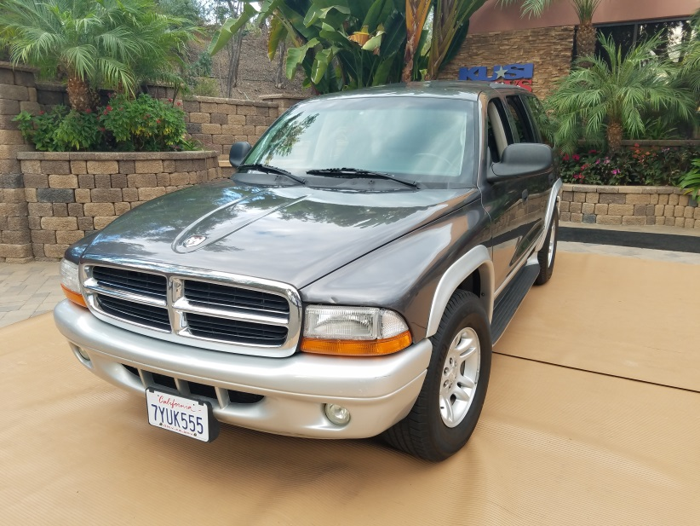
Justin Burtnett

2002 Dodge Durango

MILITARY VEHICLE GIVEAWAY Car for a Cause is Absolutely Free / No Purchase Necessary / No Gimmick

Do you know a military person or family that could use a little help?
Between September 1st and October 31st friends and family nominated you to win a vehicle by submitting an official entry online at www.carforacause.com

WHATS NEXT: A representative from San Diego Auto Repair Care will contact you to set a date & time to complete the vehicle registration in your name and complete the Car for a Cause Official Rules 2017 form.

*Vehicle transfer will occur on KUSI TV San Diego 7:00am November 19th, 2017
You are welcome to bring family & friends that nominated you!
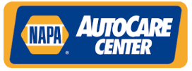
SUPPORT: WHY WE DO IT
“NAPA and NAPA AutoCare Centers has a very large military family, including our employees and our customers who have served or are actively serving in the armed forces. One of our community events this year is to assist the military during difficult financial times by providing a free vehicle. “Car for a Cause”
Thank You For Your Service In The Military!
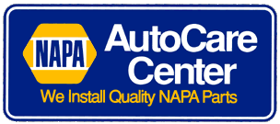
Sponsors

www.sandiegoautorepaircare.com

Aero Auto Repair 858-467-9999 Convoy Auto Repair 858-560-9131
9756 Aero Drive 3909 Convoy Street
San Diego, Kearny Mesa, CA. 92123 San Diego, Kearny Mesa, CA. 92111
www.aeroautorepairsandiego.com service@convoyautorepair.com

FTS Auto Repair 858-279-7724 John’s Automotive Care 619-280-9315
3727 Convoy Street 6267 Riverdale St.
San Diego, Kearny Mesa CA. 92111 San Diego, Allied Gardens CA. 92120
www.ftsauto.com www.johnssandiegoautorepair.com

Pacific Auto Service 858-457-1977 Asmars Auto Care 619-589-1188
7451 Trade Street, Suite A 8621 Troy Street
San Diego, Miramar CA. 92121 Spring Valley, CA. 91977
www.pacificautoservice.com www.asmarsautocare.com

Lee Rollins Firestone 858-457-3133 Boulevard Automotive 858-488-7573
5760 Miramar Rd. 737 Turquoise Street
San Diego, Miramar CA. 92121 San Diego, La Jolla CA. 92109
www.leerollinsfirestone.com www.lajollapbautorepair.com

Performance Specialties 619-461-2682 Bonita Valley Auto Care 619-475-1714
845 Grand Ave. 3995 Bonita Road
Spring Valley, Spring Valley CA. 91977 Bonita, Chula Vista, CA. 91902
www.napaautocare.com www.bonitavalleyautocare.com

Bonita Point Auto Care 619-421-7600 Griffins Auto Repair 619-234-7991
1495 East H Street 1542 State St.
Chula Vista, Chula Vista CA. 91910 San Diego, CA. 92101
www.bonitapoint76.com www.griffinsautorepair.com
Mission Hills Automotive 619-299-9367 Texas St. Auto Clinic 619-297-0189
308 West Washington St. 2404 El Cajon Blvd.
San Diego, CA. 92103 San Diego, North Park CA. 92104
www.missionhillsautosd.com www.napaautocare.com

West El Cajon Automotive & Trans 619-440-4044 NAPA Auto Parts 619-300-4910 844 North Johnson Ave, 7440 Convoy Ct.
El Cajon, CA. 92020 San Diego, CA. 92111
www.westelcajonauto.com John Hartman S.D.A.R.C. Representative
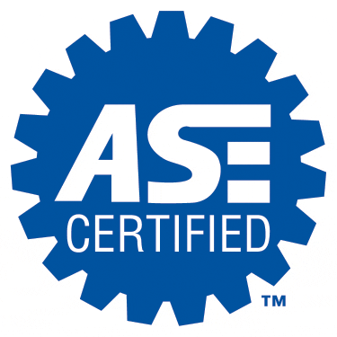
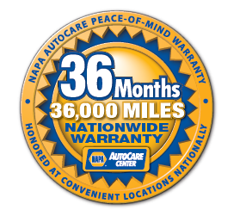
All Locations offer ASE Certified Technicians and a 36 Month / 36,000 Miles Nationwide Warranty!

